N8N documentation Course

Author:Fouenang Miguel Bruce
Date:27/10/2025
Address:miguelfouenanf@gmail.com

Introduction

This cause is is a Udemy designed course for me start Learning n8n from scratch so that can I can build workflows to automate my tasks.

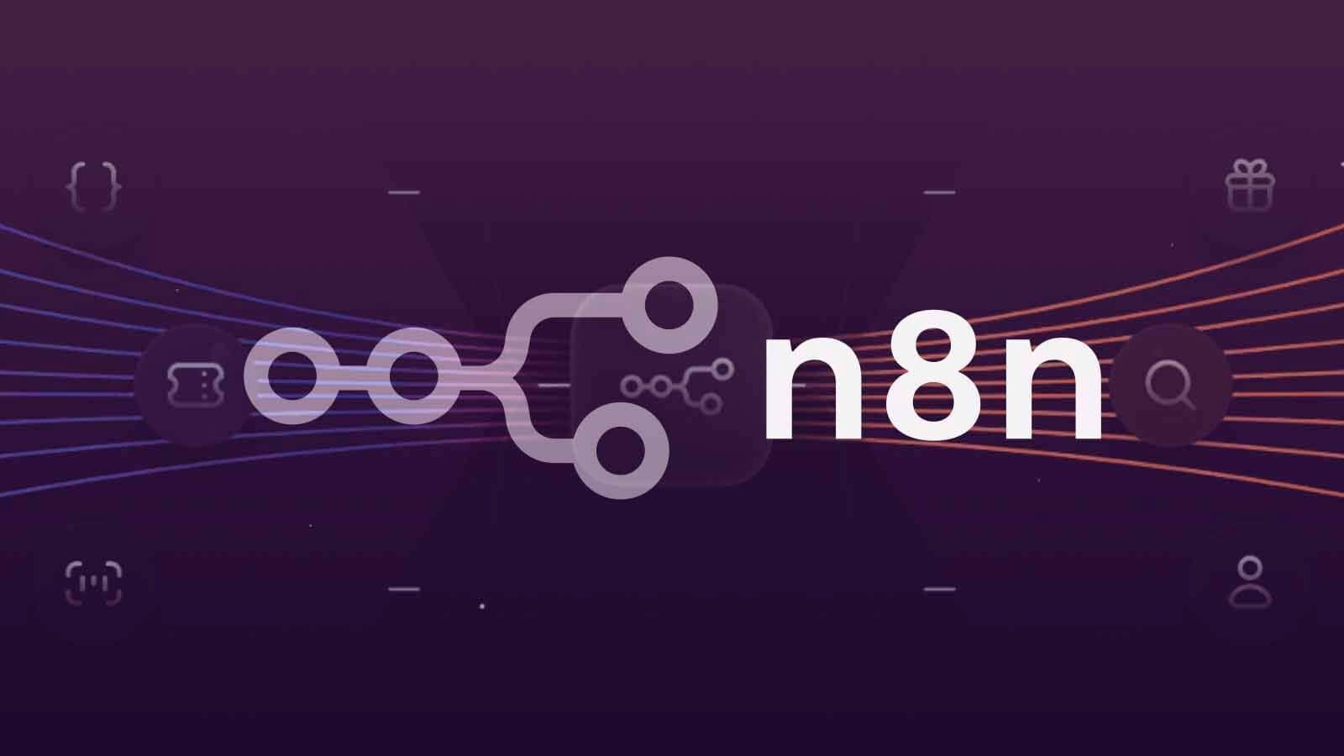
Note that n8n is a complete open-source tool that is it is available for every one. On like Zabbix and make n8n is has the main propose to automate repetitive tasks so it help us to do things better and faster.

How does n8n Works

What is a workflow : A workflow is a sequence of connected nodes. So a workflow can be seen defined as an interconnection of nodes in order to permit task automation .With n8n we can automate the time,delay of the execution of a process and even a transition between processes. When using n8n we can easily connect our nodes with API and also used the n8n to create full automatic apps.

Setting n8n on Linux

Since I’m actually a Linux user I gonna give the way on method of installation of n8n.We can either pass through the documentation but I will do it myself. On Linux we mainly have two methods of installing n8n which are :

1.Through Docker
2.Using NodeJs

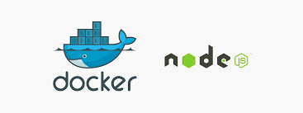

- Using Docker: This is a more stable method that I personally used to set up me n8n on my Pc
for this process we need to install docker and docker-compose on our computer to do this we gonna open the terminal and enter the following commands.

sudo apt install docker docker-compose -y

Then Configure the our docker-compose for that we gonna add an n8n folder in our pc using the commands in our terminal
mkdir n8n && cd n8n

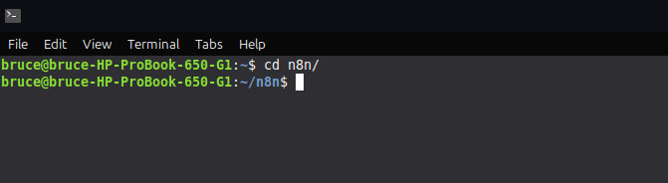

We gonna be here after doing this then create a docker-compose.yml file to launch and used n8n

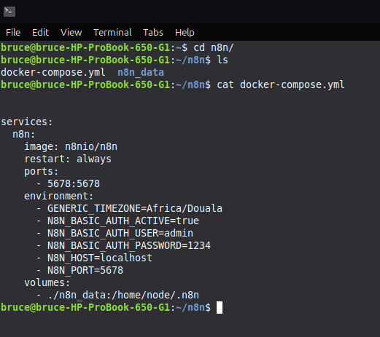
aaa

We can clearly see the contain me docker-compose.yml file this file.

Note:ChatGPT and DeepSeek can generate this type of files for you.

Now let run of program using the commands “docker compose up -d” For the first launch some files will be downloaded in other to set up the container configurations. When successful move on the our browser and move the absent “http://localost:5678”

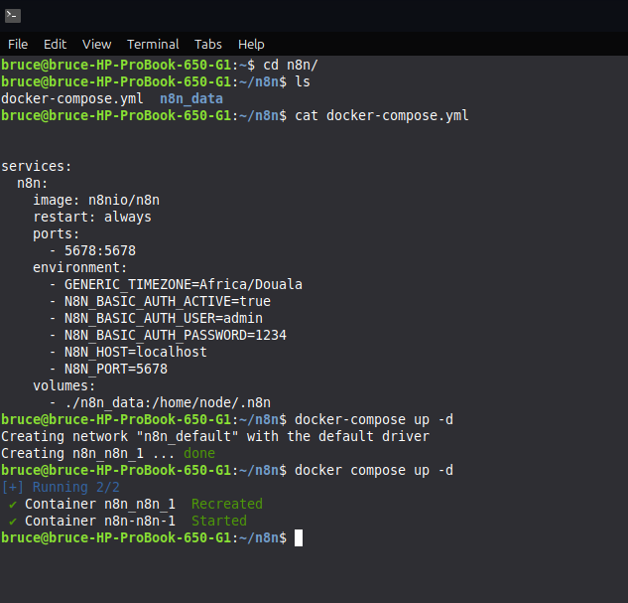

This is actually the n8n dashboard where I work.

Before we meet this section we need to login and enter our username.

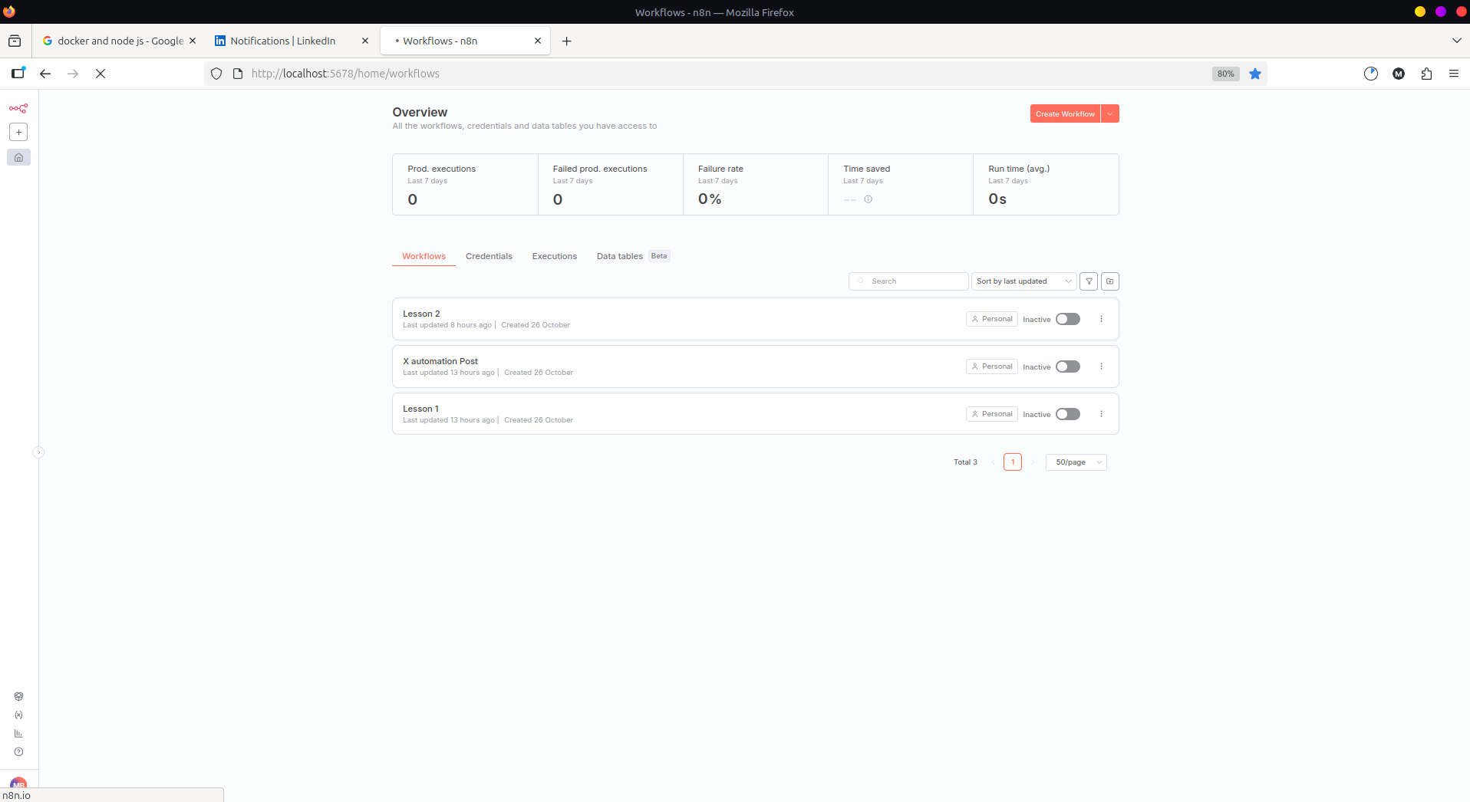

Method 2:Using NodeJS

This method is less stable than using docker but if still a good aspect for using n8n with node js we gonna need to install newer version of nodejs that is a version greater the version 18.To do that used the commands.

“sudo apt install nodejs npm -y”

check installation using the node -v and npm -v.
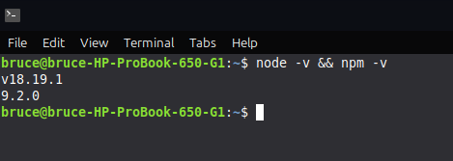

Now let install n8n globally on our pc
“npm install n8n -g”

Then run the command n8n on our pc to launch it. Now move on the browser and type “http:localhost:5678”

Some docker commands :
1.TO List our containers “docker ps”
2.List all container on PC : “docker ps -a”
3.Solve access permission :sudo chown -R home/user/n8n/n8n_data

Important nodes

When using n8n we mainly found 3 types of node which are the

1.Trigger Nodes:
The include the following types of notes

- Start node:Used for starting our workflow
- Webhook node:Using the set Api connections in our workflow
- Manual trigger:Manually setting up our workflow

2.Data and Logic node :

- Set node:Used to Write and send text messages
- Function node:Used for the creation of Js functions so mainly the node that will contain all our program logic.
- IF node :Used to the setting either true of false conditions
- Switch node:Using to add more options in our workflow for decision making so the IF node gives two conditions while the switch node offers us cases.
- Walt node:Use to set up a timer for our different nodes activation.

3.Integration and Communication Nodes

- HTTP Request node:node used to handle all HTTP and HTTPS requests to our workflow so like like webhooks it permit our workflow to communicate with the exterieur.
- Email node : Node used to handle emails into and out of our workflow.
- Telegram node:used to handle all types of telegram works.
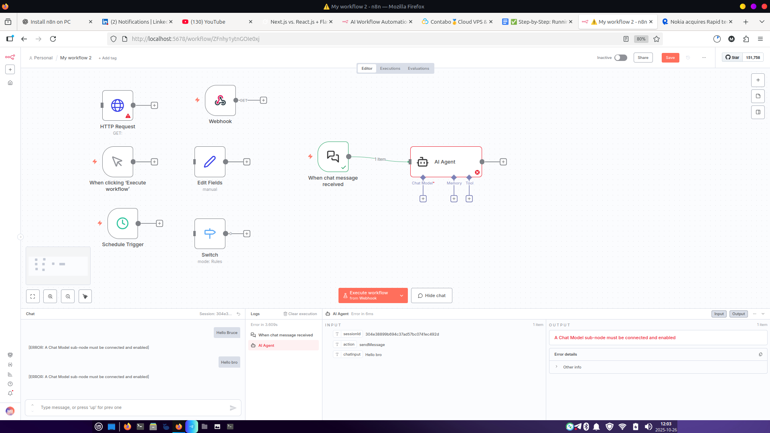

Now to go further I gonna build a custom chat bot on n8n using Gemini api

1.Create a new workflow and name it Custom Chatbot
2.Select a chat messages node
3.Select and add and IA agent
4.To the AI add a simple sqlite memory
5.Move to Google Studio API and get the Google gemini Api

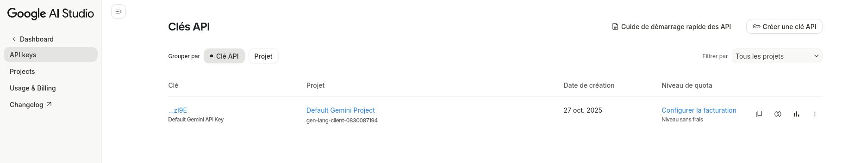

6.Create a new credential and connected the API to it using the API generated key.
7.Used the Custom chatbot and send your messages.

